1)Introduction and setup

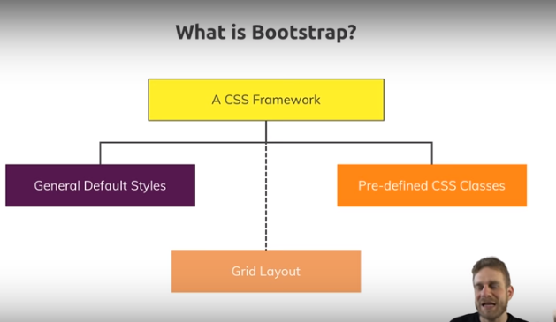

Bootstrap covers 3 things-

1)some defaults styles- its sets up defaults font sizes ,padding, margins ,colors etc. so lot of styling applied to headings, paragraphs and so on.

2)predefined css classes

3)grid- idea behind grid is you can layout the page with grid.

Lets look at them in detail now.

First is general styles. general styles simply means for one there is general package called reboot created by bootstrap team. Which styles a lot of things on your page so that ,they look and behave same in all browsers. Each browser comes with own set of default styles, so some elements can look or behave a bit different in different browsers. So reboot is part of bootstrap which makes sure that we all start on same page.

There after ,there are default typography styles. so style for headings ,paragraphs, span and so on. So all these default html elements that you use a lot,to construct your page, all receive standard styles by bootstrap packages. Last is tables images and figures, these also receive style to look good. So this is default styling. You get these styles applied to certain elements , no matter whether you want them or not. Obviously you want them , otherwise why would you use bootstrap. We can still override them with our own css rules, I will say that, but this is what you start with.

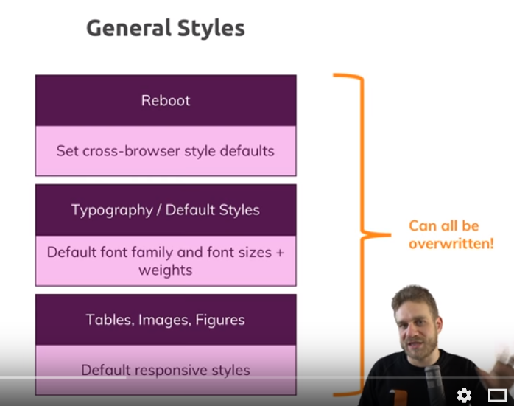

The next building block is grid layout. As I said, you can thing of your page as bunch of rows and columns. grid layout in bootstrap is defined by, lets say a div with container css class. Container contains the grid that you define with couple rows and columns. Therefore in a container we got one or more rows. In rows we have one or more columns. You create rows or columns by nesting divs or any other block level html element and assigning row, col or container class.

Regarding columns there actually are different classes you can use ,to make your grid responsive, to define how broad certain columns should be for certain device sizes, so you can say on mobile devices I want to have my 2 columns not sitting next to each other but beneath each other. so each column should take full width. While on bigger devices we want to have 2 columns sitting next to each other, each columns taking 50% of total width. These are things you can easily define by assigning right css classes. We will look at them later.

Behind the scene grid system of bootstrap uses flexboxes, - a css technology that you can use without bootstrap too ofcourse. Using it without bootstrap is not difficult but it is more work than just using some css classes. So bootstrap is easier.

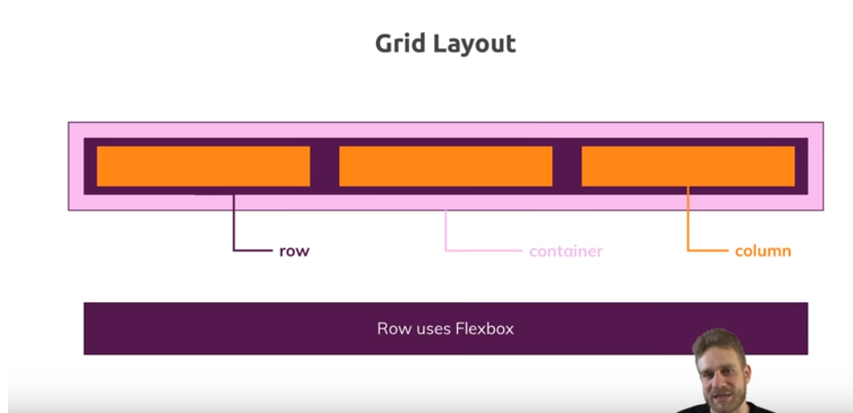

The last thing that bootstrap ships with is predefined css classes. We can also call them components. Dnt mistake them with components of view ,react or angular. You are nor adding any js logic here, through technically there are bootstrap components which contians some javascript. But I am simple talking about css classes which we simply add to html elements to make them look into a certain way. the part about js that I mentioned, well,some things like modal which can be shown or hidden, need js to toggle certain styles and bootstarp ships with js , just to do that. You can add it to your code if you want, you dnt have to. you can also toggle right classes manually , because in its core bootstrap is about classes but it gives you that extra javascript too , if you want it. We will see how to use it in a second. lets see some of these pre defined classes-

We have alert of different colors. It is just a div with certain css class, that makes it look like this. We can add it to our page and show it if we want to draw attention of user.

We also have buttons of different colors. They have styles different thn styles that browsers gives to buttons by defaut. We have cards where we can add some images, text and buttons etc. the we have forms, we can add nice looking forms. We can add navigation bar with links , search bar etc. all these are highly configurable. We can add one css class and connect with others to get different look, for ex- the navbar. We can define navbar with css class and then add a pran by nesting another element with another class in it. We will see all these things in this course. this is what I mean by components with predefined classes though.we can make html elements looks like this just by adding right classes.

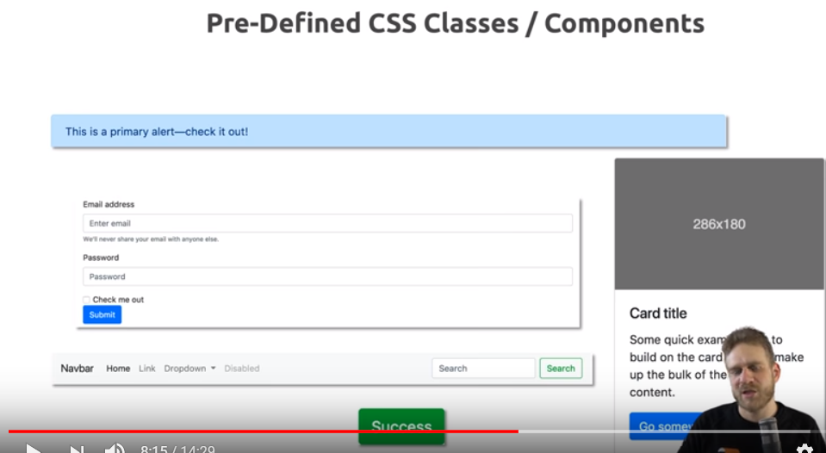

To make all this work we need bootstap. Go to getbootstrap.com. then click on getstarted,

<https://getbootstrap.com/docs/4.0/getting-started/introduction/>

there will find instruction on how to add it to your project. Easisst way is to use CDN links. These are simply html elements, import elements for css and scripts, which you can copy and paste in you projects. Like this link-

<link rel="stylesheet" href="https://maxcdn.bootstrapcdn.com/bootstrap/4.0.0/css/bootstrap.min.css" integrity="sha384-Gn5384xqQ1aoWXA+058RXPxPg6fy4IWvTNh0E263XmFcJlSAwiGgFAW/dAiS6JXm" crossorigin="anonymous">

Then you add this link in head section of your html. Now this will import bootstrap styling, so the css file from cdn and CDN means from a different server which is highly optimized for speed. Often importing from cdn is faster than importing from your local server, so using CDN links is option that you should consider. Now besides importing css, you can also import js. You will find links in same place, these will import jquery, popper (another third party package) and bootstrap js code.

<script src="https://code.jquery.com/jquery-3.2.1.slim.min.js" integrity="sha384-KJ3o2DKtIkvYIK3UENzmM7KCkRr/rE9/Qpg6aAZGJwFDMVNA/GpGFF93hXpG5KkN" crossorigin="anonymous"></script>

<script src="https://cdnjs.cloudflare.com/ajax/libs/popper.js/1.12.9/umd/popper.min.js" integrity="sha384-ApNbgh9B+Y1QKtv3Rn7W3mgPxhU9K/ScQsAP7hUibX39j7fakFPskvXusvfa0b4Q" crossorigin="anonymous"></script>

<script src="https://maxcdn.bootstrapcdn.com/bootstrap/4.0.0/js/bootstrap.min.js" integrity="sha384-JZR6Spejh4U02d8jOt6vLEHfe/JQGiRRSQQxSfFWpi1MquVdAyjUar5+76PVCmYl" crossorigin="anonymous"></script>

This contains all the code that we need for certain components that rely on js like modal that I already mentioned. For time being we are not adding this to our project but we will revisit it when we will add js driven components. So this is quickest way of getting started but not only one.

On left side of page you will see see download, click on it to see all optons. This is link-

<https://getbootstrap.com/docs/4.0/getting-started/download/>

Beside cdn link, you can also download the compiled and optimized css and js files.clcik on download, zipfile will be downloaded. In index.html import them. When you deploy your code, they will be shipped with your code to server. They will served from our server. Advantage is, if your server is up, then these files will be reachable, where as theoretically CDN can be down. But as I mentioned ,cdn’s are highly optimized for realiablity and speed. So often going with cdn is best.

You can also grab source file(see below, CDN link on official site). Now what does it means? Bootstrap is actually written in scass, which is superset to css, you could say. It is different language that does’nt run in browser, it needs to be compiled to normal css during development. It allow us to write convenient code,It gives us more features, it makes writing css code easier. That’s why bootstrap team used it. You can download that raw source code and therefore you can change every tiny bit of bootstrap in very simple manner but ofcourse that would require workflow that compiles it to css and it is a bit more advance. But you can download it if you want. You can also see which tools you will need to work with it(in official docs).

Last options is to use package manager like npm. When you are uing advance js frameworks like anglar, react or vue we use npm or yarn to manage our dependencies.

So we run-

**npm install bootstrap**

this will download bootstrap in node_modules folder and we can import it from there. Either by adding import links in index.html like we added for CDN links, just pointing to node_modules folder. but that is not optimal, because often you do not deploy node_modules. Better way will be to import css and javascript files into your other project,s javascript files since you typically have a build workflow using webpack which will understand this kind of import thing and which will then simply take care that your dependencies gets copied into your production folder correctly. This is complex, go thorugh max’s webpack if you want to learn it. You will be using webpack if you are building more complex project. In this course we will go by CDN approach.

Now open index.html in browser. Here inspect the h1 element.

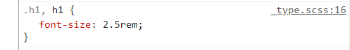

In dev tools we can se that a fontsize is applied to h1 which is not default. It is coming from bootstrap. In dev tools you can also see that it is coming from _type.scss file. it is this sass , or very precise scss(wich is type of saas) file that we mentioned in raw code section. Now we did’nt downloaded the raw source code but compiled and optimized file which gets downloaded from cdn,which you can check by visiting the network tab in chrome dev tools . in network tab oyu can see bootstrap file being downloaded. Click on it to see its content. You will see that it has source mapping, which is simply the information that allow brower to translate compiled code to raw code. So because of this we can see refrence to raw code in styles tab of chrome dev tools.

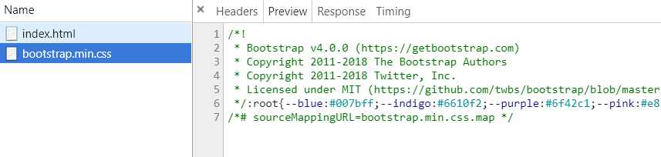

But here core takeaway is this style is coming from bootstrap, this is not some default browser style. This also means tat we have successfully imported bootstrap.